Vocabulary Two: Civilizations of Mesoamerica
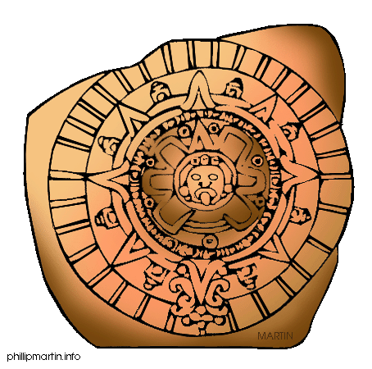
MONDAY: Connections and Predictions
DIRECTIONS: Rewrite each word, and write a connection – what does the word make you think of or what do you think the word means?
EXTRA CREDIT: Set a goal for yourself this week. What is one thing you want to improve or achieve?

 | Word | Rewrite the Word | Make a Connection: What does the word make you think of or what do you think it means?
1 | agriculture
2 | slash-and-burn
3 | Tenochtitlán
4 | Tikal
5 | irrigate
6 | chinampa
7 | causeway
8 | suspension bridge
9 | aspect
10 | motive

Vocabulary Two: Civilizations of Mesoamerica
TUESDAY: Synonyms and Explanations
DIRECTIONS: Find a SYNONYM for each word. Write an alternate (different) definition using the synonym.
Word | Definition | Synonyms Other words that can be used instead of this one. | Alternate (Different) Definition
agriculture (n) | growing crops and animals for food
slash-and-burn agriculture (n) | cutting down and burning vegetation to clear land so crops can be grown
Tenochtitlán (n) | a great city built on an island that became the center of the Aztec Empire | XXXXX
Tikal (n) | one of the largest and most powerful Mayan city-states | XXXXX
irrigate (v) | to supply land or crops with water
chinampa (n) | a floating garden made of mud and plants used by the Aztecs to increase farmland
causeway (n) | a raised road across water or wet ground
suspension bridge (n) | a bridge that has no supports under it, but hangs from strong ropes or cables attached to towers or cliffs
aspect (n) | a part or feature for example: School is only one aspect of my life.
motive (n) | something that causes a person to act in a certain way; an incentive

WEDNESDAY: Word Squares
DIRECTIONS: Complete word squares by writing each word, writing the definition, writing a synonym and drawing a picture showing what the word means.
Example:
Suspension Bridge | a bridge that hangs from cables attached to towers or cliffs
hanging bridge | 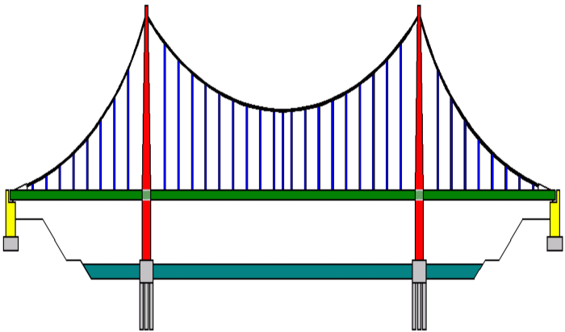

THURSDAY: Writing a Story or Summary
DIRECTIONS: Write a paragraph that uses at least 8 vocabulary words. The paragraph must have at least 6 sentences.
Ideas: write a creative story or write a summary of what you have learned in class
__________________________________________________________________________________________________________________________________________________________________________________________________________________________________________
____________________________________________________________________________________________________________________________________________________________
____________________________________________________________________________________________________________________________________________________________
____________________________________________________________________________________________________________________________________________________________
____________________________________________________________________________________________________________________________________________________________
____________________________________________________________________________________________________________________________________________________________
____________________________________________________________________________________________________________________________________________________________
____________________________________________________________________________________________________________________________________________________________
____________________________________________________________________________________________________________________________________________________________
______________________________________________________________________________
______________________________________________________________________________

EXTRA CREDIT: On a separate sheet of paper, attach a reflection. Think about your goal for this week. Did you achieve it? What was helpful to you? What was difficult? What can you do better next week?

