Vocabulary Three: Civilizations of Mesoamerica
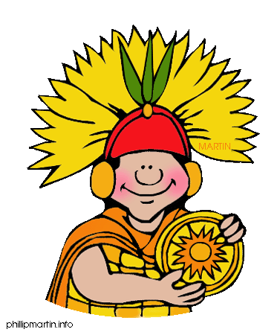
MONDAY: Connections and Predictions
DIRECTIONS: Rewrite each word, and write a connection – what does the word make you think of or what do you think the word means?
EXTRA CREDIT: Set a goal for yourself this week. What is one thing you want to improve or achieve?

 | Word | Rewrite the Word | Make a Connection: What does the word make you think of or what do you think it means?
1 | Machu Picchu
2 | ritual
3 | sacrifice
4 | observatory
5 | llama
6 | rebel
7 | Conquistador
8 | decline
9 | evaluate
10 | identify

Vocabulary Three: Civilizations of Mesoamerica
TUESDAY: Synonyms and Explanations
DIRECTIONS: Find a SYNONYM for each word. Write an alternate (different) definition using the synonym.
Word | Definition | Synonyms Other words that can be used instead of this one. | Alternate (Different) Definition
Machu Picchu (n) | large Incan ruins in the Andes Mountains of Peru | XXXXX
ritual (n) | a set of actions that is always done the same way as part of a religious ceremony
sacrifice (n) | the offering of an animal or human life to a god
observatory (n) | a place or building used for viewing or observing the planets and stars
rebel (n)  [reb-uhl] | a person who fights against authority
rebel (v)  [re-bell] | to resist or fight against authority or control
conquistador (n) | a Spanish soldier who explored America and conquered native peoples
decline (v) | to weaken or lose power
evaluate (v) | to determine or judge the importance or value of something
identify (v) | to name or list; to choose

Vocabulary Three: Civilizations of Mesoamerica
WEDNESDAY: Word Squares
DIRECTIONS: Complete word squares by writing each word, writing the definition, and drawing a picture showing what the word means.
THURSDAY: Writing a Story or Summary
DIRECTIONS: Write a paragraph that uses at least 8 vocabulary words. The paragraph must have at least 6 sentences.
Ideas: write a creative story or write a summary of what you have learned in class.
__________________________________________________________________________________________________________________________________________________________________________________________________________________________________________
____________________________________________________________________________________________________________________________________________________________
____________________________________________________________________________________________________________________________________________________________
____________________________________________________________________________________________________________________________________________________________
____________________________________________________________________________________________________________________________________________________________
____________________________________________________________________________________________________________________________________________________________
______________________________________________________________________________
____________________________________________________________________________________________________________________________________________________________
____________________________________________________________________________________________________________________________________________________________
____________________________________________________________________________________________________________________________________________________________
______________________________________________________________________________
EXTRA CREDIT: On a separate sheet of paper, attach a reflection. Think about your goal for this week. Did you achieve it? What was helpful to you? What was difficult? What can you do better next week?

