Vocabulary One: Civilizations of Mesoamerica
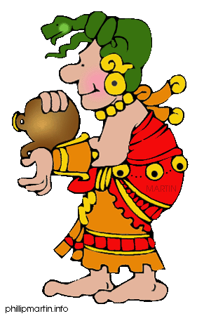
MONDAY: Word Pyramids
DIRECTIONS: In the space below, create a word pyramid for each term.
EXTRA CREDIT: Set a goal for yourself this week. What is one thing you want to improve or achieve?

VOCABULARY:
1. Mesoamerica
2. Elevation
3. Theory
4. Civilization
5. Ruins
6. Polytheism
7. Tribute
8. Mercenary
9. Analyze
10. Complex
EXAMPLE:
S
St
Stu
Stud
Study

TUESDAY: Connections and Predictions
DIRECTIONS: Rewrite each word, and write a connection – what does the word make you think of or what do you think the word means?
 | Word | Rewrite the Word | Make a Connection: What does the word make you think of or what do you think it means?
1 | Mesoamerica | Mesoamerica | A place in America.
2 | elevation
3 | theory
4 | civilization
5 | ruins
6 | polytheism
7 | tribute
8 | mercenary
9 | analyze
10 | complex

WEDNESDAY: Synonyms and Explanations
DIRECTIONS: Find a SYNONYM for each word. Write an alternate (different) definition using the synonym.
Word | Definition | Synonyms Other words that can be used instead of this one. | Picture or Example
ruins (n) | The parts of a building or city that is left after the rest has been destroyed. | Remains
elevation (n) | The distance of a place above the level of the ocean (sea level), the height of a location
theory (n) | an idea that tries to explain something about life or the world (especially if it hasn’t been proven true!)
civilization (n) | A well-developed (large) society or group of people.
Mesoamerica (n) | Mesoamerica is the land area stretching from southern Mexico through Central America. | Meso = middle
polytheism (n) | The idea that more than one god exists* | *Polytheism is the idea that more than one god exists. A polytheist is a person who believes in polytheism. The word polytheistic is used to describe someone or something related to polytheism such as: The religion of Greece was polytheistic.
tribute (n) | A payment made by ruler or group to another ruler for protection or to show loyalty and respect.
mercenary (n) | A soldier who is paid to fight for another group or ruler.
analyze (v) | To closely study or carefully think about something to better understand it.
complex (adj) | When something is difficult to understand or has many different parts

THURSDAY: Writing a Story or Summary
DIRECTIONS: Write a paragraph that uses at least 8 vocabulary words. The paragraph must have at least 6 sentences.
Ideas: write a creative story or write a summary of what you have learned in class.
__________________________________________________________________________________________________________________________________________________________________________________________________________________________________________
____________________________________________________________________________________________________________________________________________________________
____________________________________________________________________________________________________________________________________________________________
____________________________________________________________________________________________________________________________________________________________
____________________________________________________________________________________________________________________________________________________________
____________________________________________________________________________________________________________________________________________________________
____________________________________________________________________________________________________________________________________________________________
__________________________________________________________________________________________________________________________________________________________________________________________________________________________________________
____________________________________________________________________________________________________________________________________________________________
______________________________________________________________________________
______________________________________________________________________________

EXTRA CREDIT: On a separate sheet of paper, attach a reflection. Think about your goal for this week. Did you achieve it? What was helpful to you? What was difficult? What can you do better next week?

