West County Community High School (Charter School)
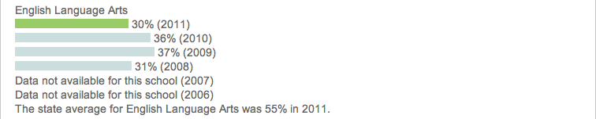
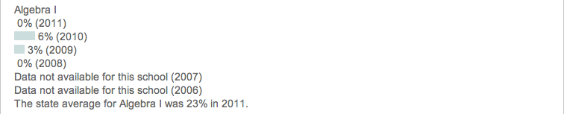
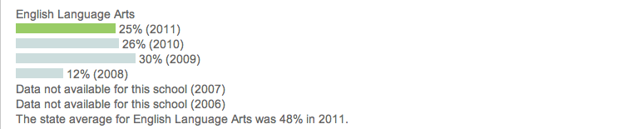
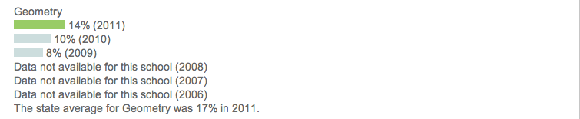
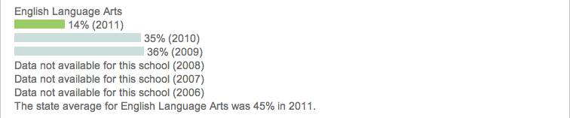
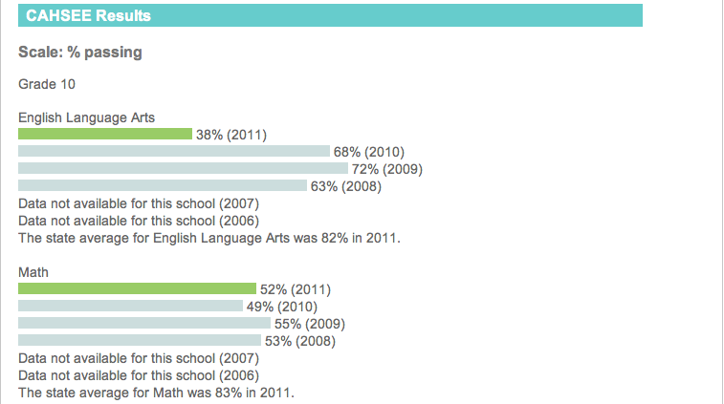

Leadership Public Schools – Richmond (Charter School)
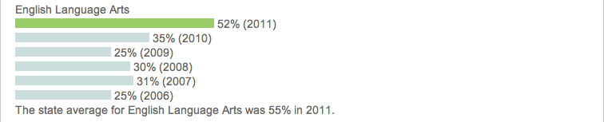
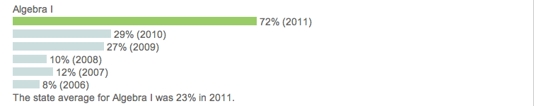
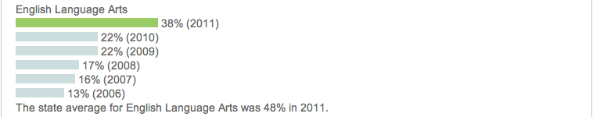

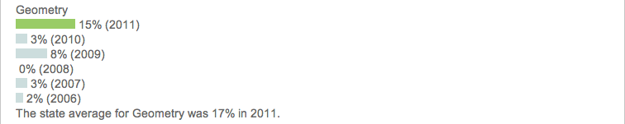
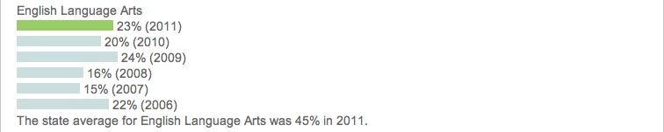
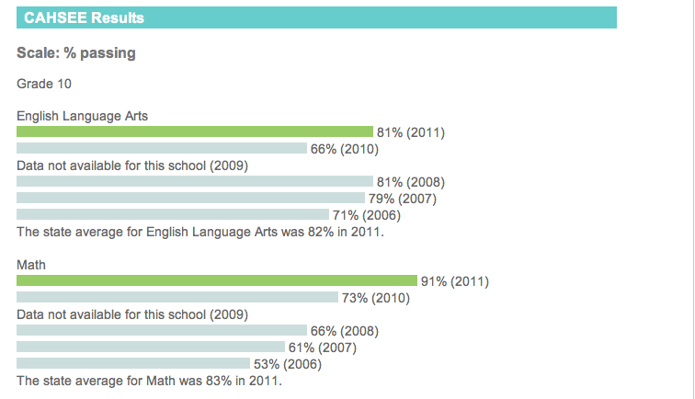

El Cerrito High School (Traditional Public School)
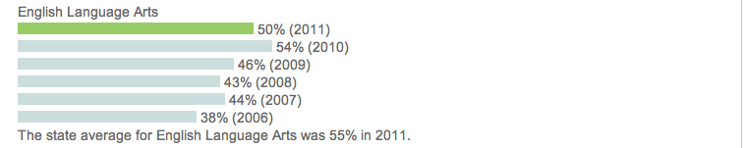
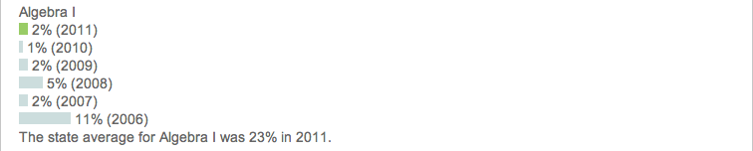
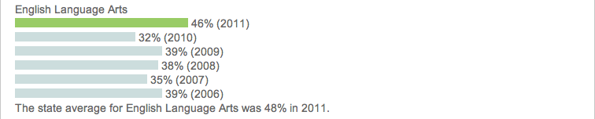
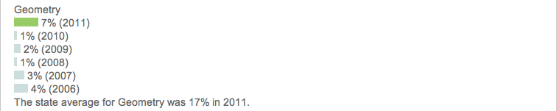
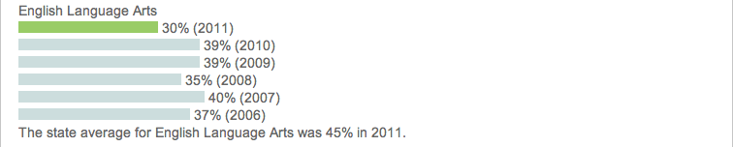
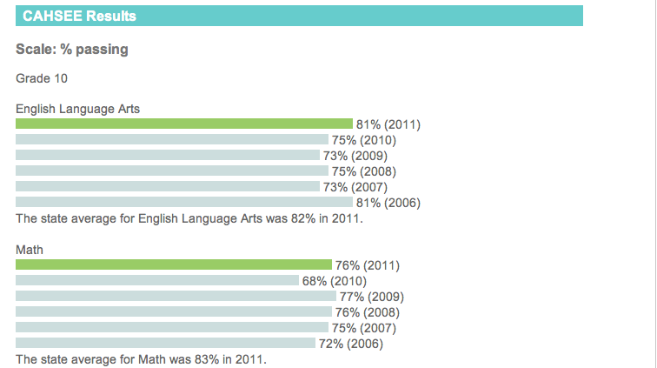

Richmond High School (Traditional Public School)
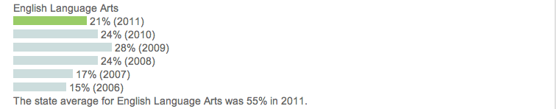
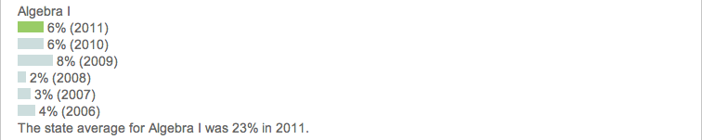
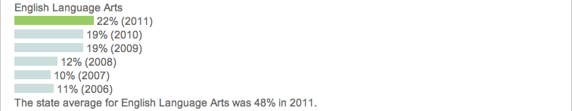
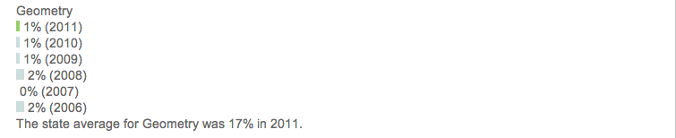
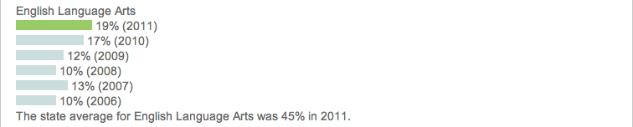
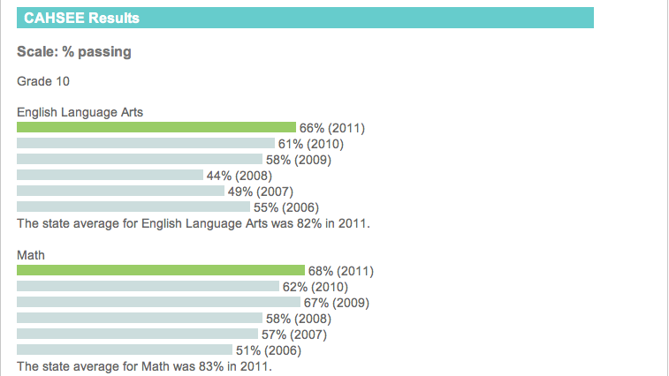

Data Reflection Questions

- In general, what do you notice about the performance of charter schools?

___________________________________________________________ ___________________________________________________________
___________________________________________________________

- What do you notice about the performance of traditional public schools?

___________________________________________________________ ___________________________________________________________
___________________________________________________________

- What is a question that you have about the data that you just looked at?

___________________________________________________________ ___________________________________________________________
___________________________________________________________

