Name_______________________________________________________ Period____________ Date______________
Circle the answer to Multiple Choice questions. Use full sentences on the free response questions.
- Longitude and latitude are used to:
- Tell the difference between cultures.
- Locate places on a world map.
- Navigate rivers.
- Get from one highway to another.

- Latitude is labeled:
  - North and East
  - West and South
  - North and South
  - East and West

- Longitude goes from:
  - North to East
  - West to South
  - North to South
  - East to West

Fill in the blanks with the appropriate letters:
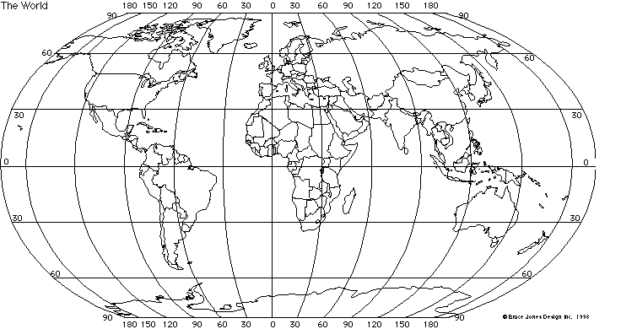
A
B
Which point is at 60 North, 90 West? _____ Which point is at 30 South, 120 East? ____

What are the latitude and longitude for one point in South America? _________________________
Guided Practice 4 – 25 minutes
Objective:
(4) SWBAT define, identify and use political maps, physical maps and resource maps. Describe the differences between political, physical and resource maps and know when to use them.

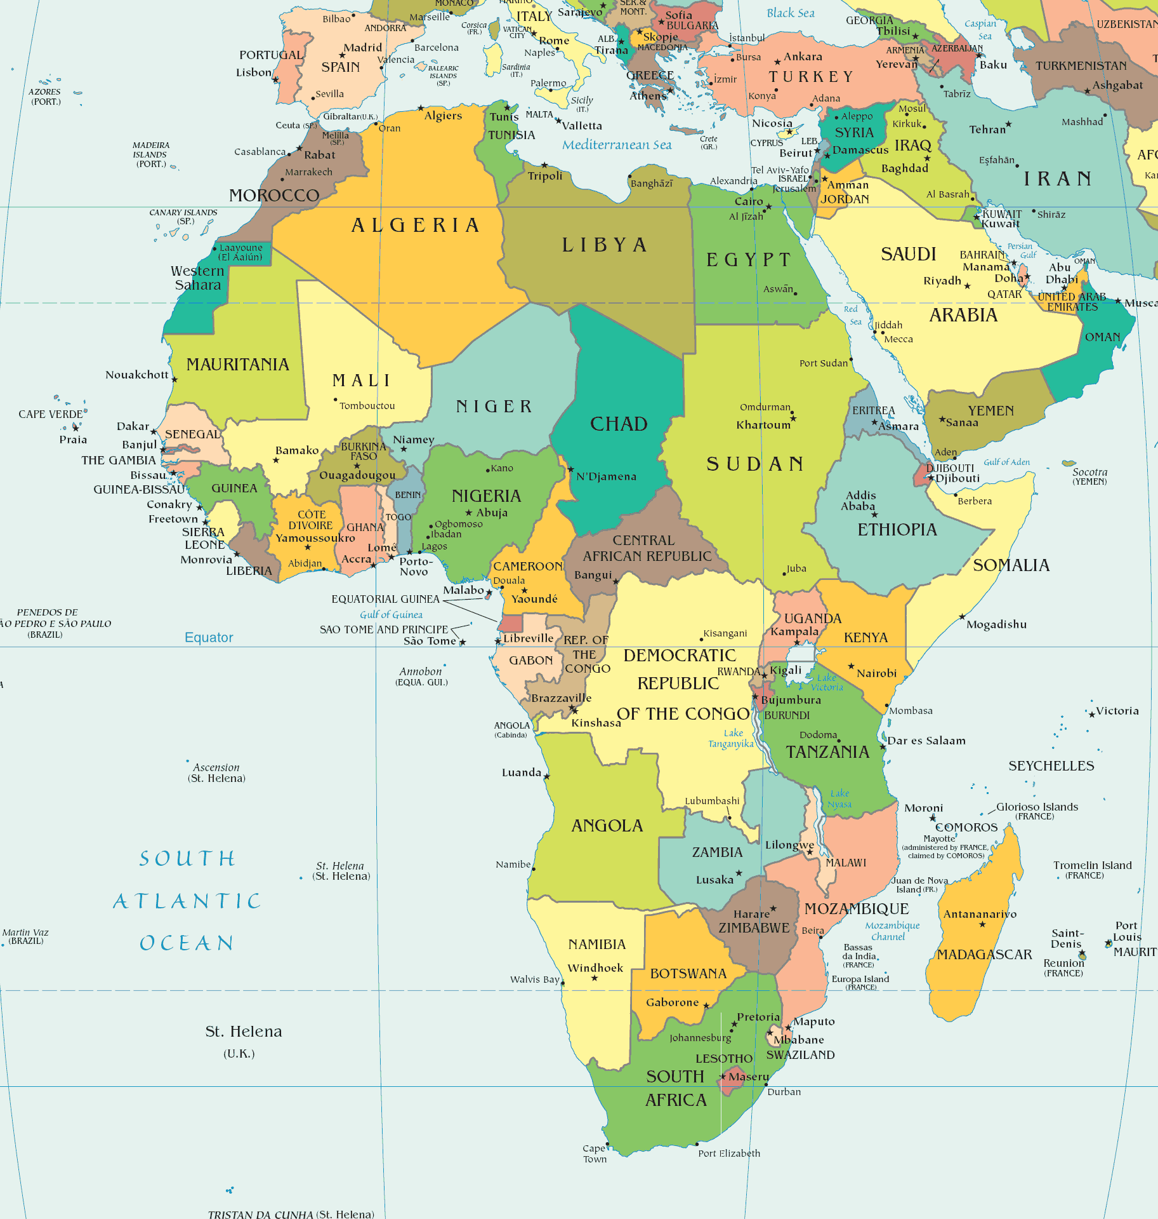

Definitions:
- Political Map:

A political map shows the __________________ of
________________________________ and states.
- Use the _____________ to find cities.
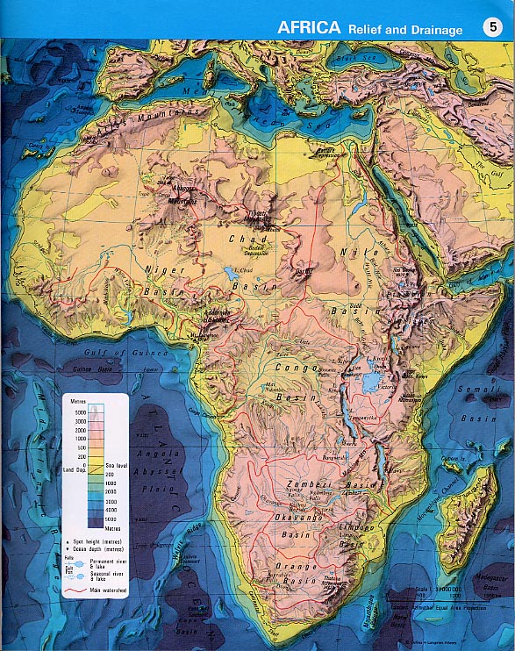
- Physical Map:

Physical maps show ___________________ features, such as
mountains, rivers, and lakes.
- Use the _____________ to find elevation.

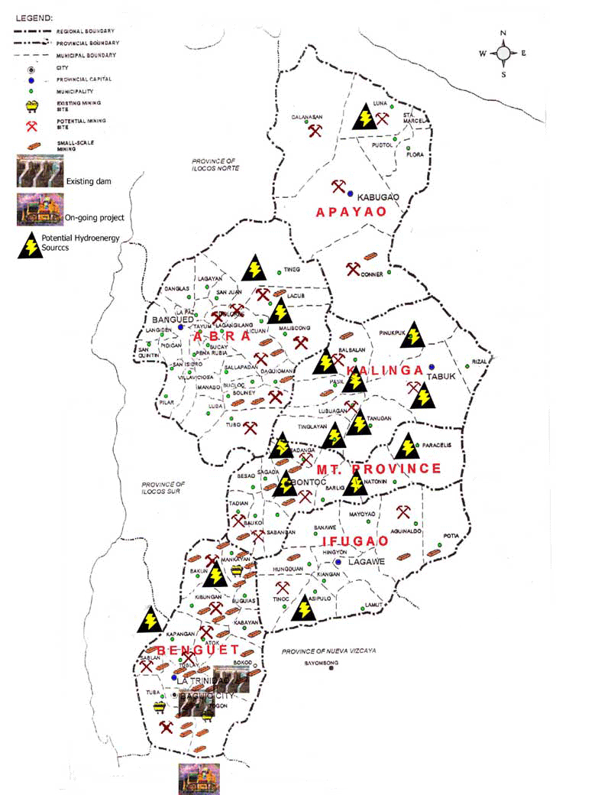
- Land Resource Map:

Resource maps show the ___________________ found in a region.

- Use the ___________ to find the location of resources.

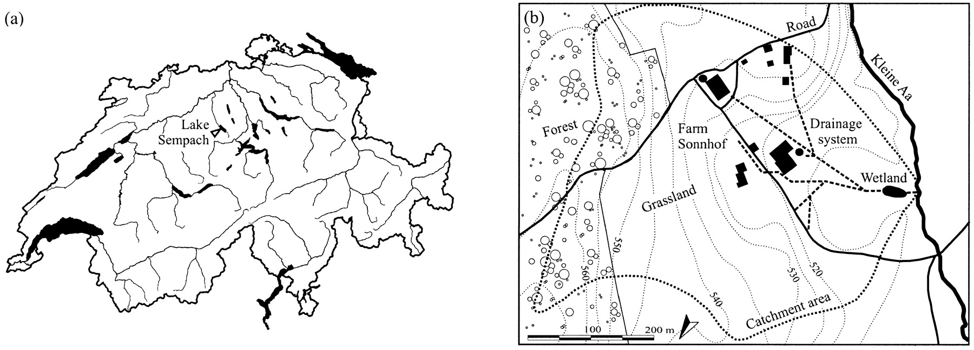
A contour map shows contour lines through points of equal _________________________.
A topographic is similar to a contour map, but can also show roads and man made features as well.

A climatic map shows the long term weather patterns of a region.
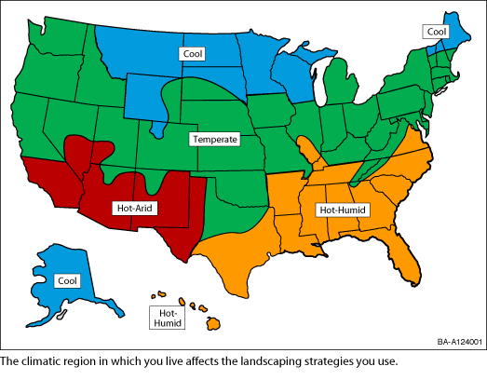
Using Political, Physical and Resource Maps

Example 1:
- This is a ______________ map.

- The capital city of Tennessee is _________________.

- The two secondary cities on the map

are ________________ and _______________.

Example 2:
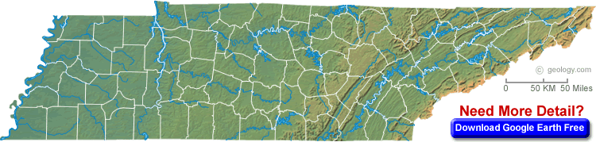

- This is a _______________ map of Tennessee.

- The mountains are in the _________________ part of Tennessee.

- The western border of Tennessee is a _______________.

Example 3:
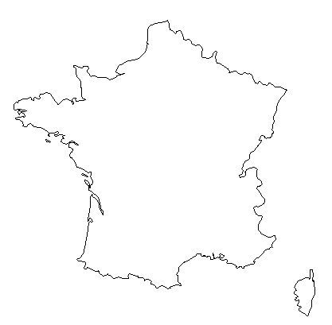
Cheese
Grapes

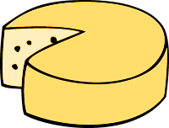
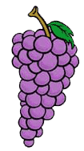
- This is a ___________________ map of France.

- ______________ is produced in the northern

part of France.

- ______________ are produced in the southern

part of France.

Example 4:
- This is a _____________________ map of Australia.
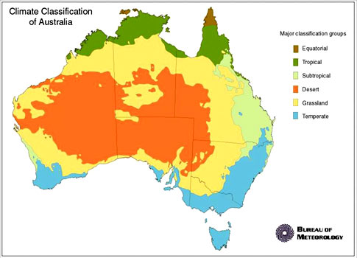
Activity
We are going on a hiking trip through a European country named Switzerland. As we make stops along the way, use the maps to answer the questions.
Chocolate

Lederhosen | 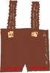

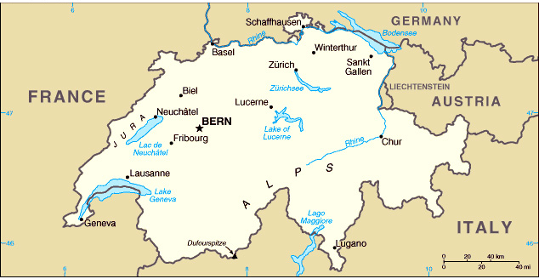

STOP 1 STOP 2 STOP 3 STOP 4 STOP 5
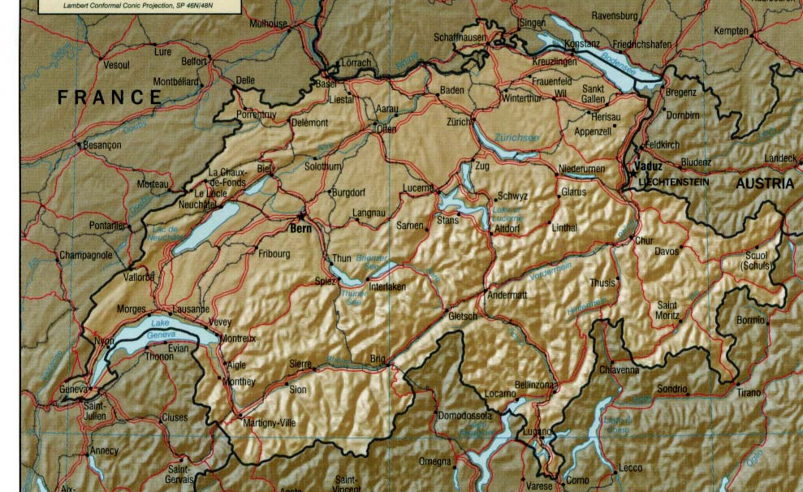

- At stop 1, we are near a __________, and we are in the

area where ___________ are made.

- At stop 2, we are in the ___________ city of Bern.

- At stop 3, we are in the ___________ city of Zurich,

and we are in the area where ____________ is made.

- At stop 4, we are in the ____________________.

- At stop 5, we are in the area where ____________ is made, we

are in the __________________, and we are next to a _________.

Independent Practice
Answer using one complete sentence.
- What does a physical map show you?

- What does a political map show you?

- What does a resource map show you?

- What does a climatic map show you?

- What does a contour, or topographic map, show you?

Only write the name of the type of map for your answer.
- What types of maps would you use to find the highest point in an area?

- What type of map would you use to find the capital city of a country?

- What type of map would you use to find where in a country corn is produced?

- What type of map would you use to find the long term weather patterns of an area?

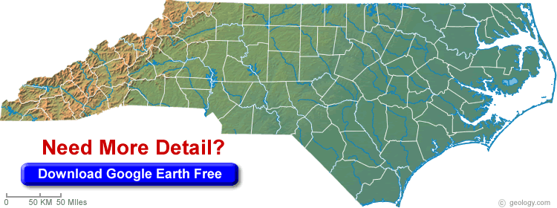
Write in complete sentences.
Question 1:

- What type of map is this?
- In what part of the state are the mountains?

Question 2:
- What type of map is this?

- Name two national capitals on this map:

- Name one city or town on this map:

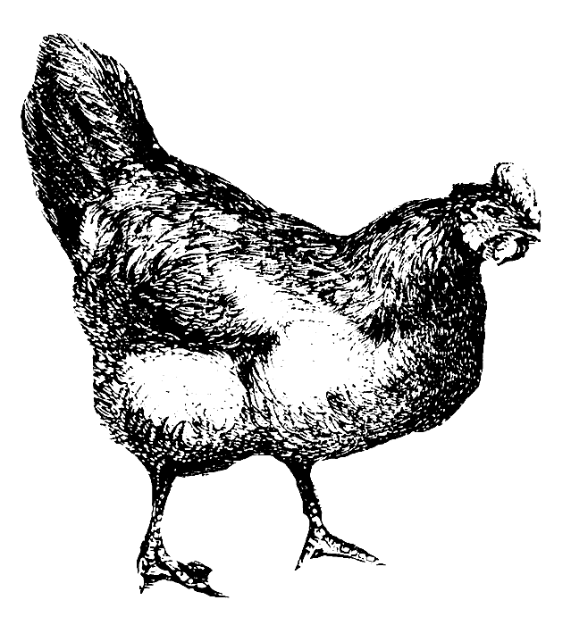
Question 3:
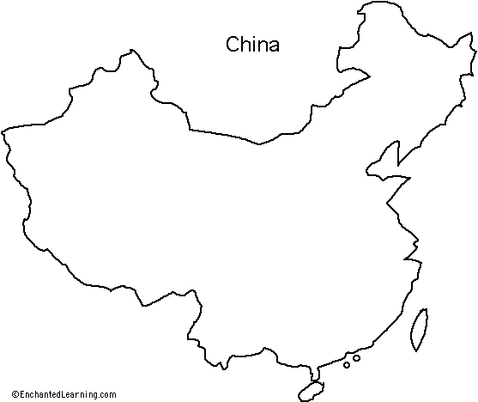
Chicken
Rice | 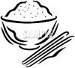
Computers

- What type of map is this?
- What is produced in the western part of China?
- Where in China is rice produced?

- What is produced in the northwestern part of
China?

ADVANCED QUESTIONS:
Use the three maps to answer the questions using full sentences.

Corn | 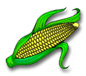
CDs | 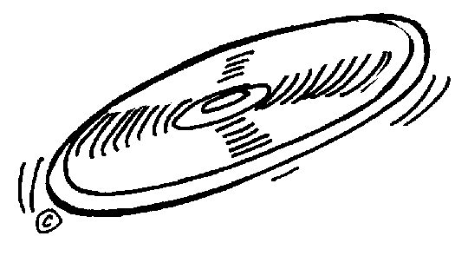

- What is produced in the area of the state that has mountains? How do you know?

- What product is made close to Memphis? How do you know?

- Are there mountains in the state capital of Tennessee? How do you know?

- Are CDs produced closer to a river or the mountains? How do you know?

Extra Practice
Circle the correct answer.

- What type of map is this map?
  - Physical Map
  - Topographic Map
  - Political Map
  - Resource Map

- Which type of map would show crop production?
  - Physical Map
  - Political Map
  - Resource Map
  - Treasure Map
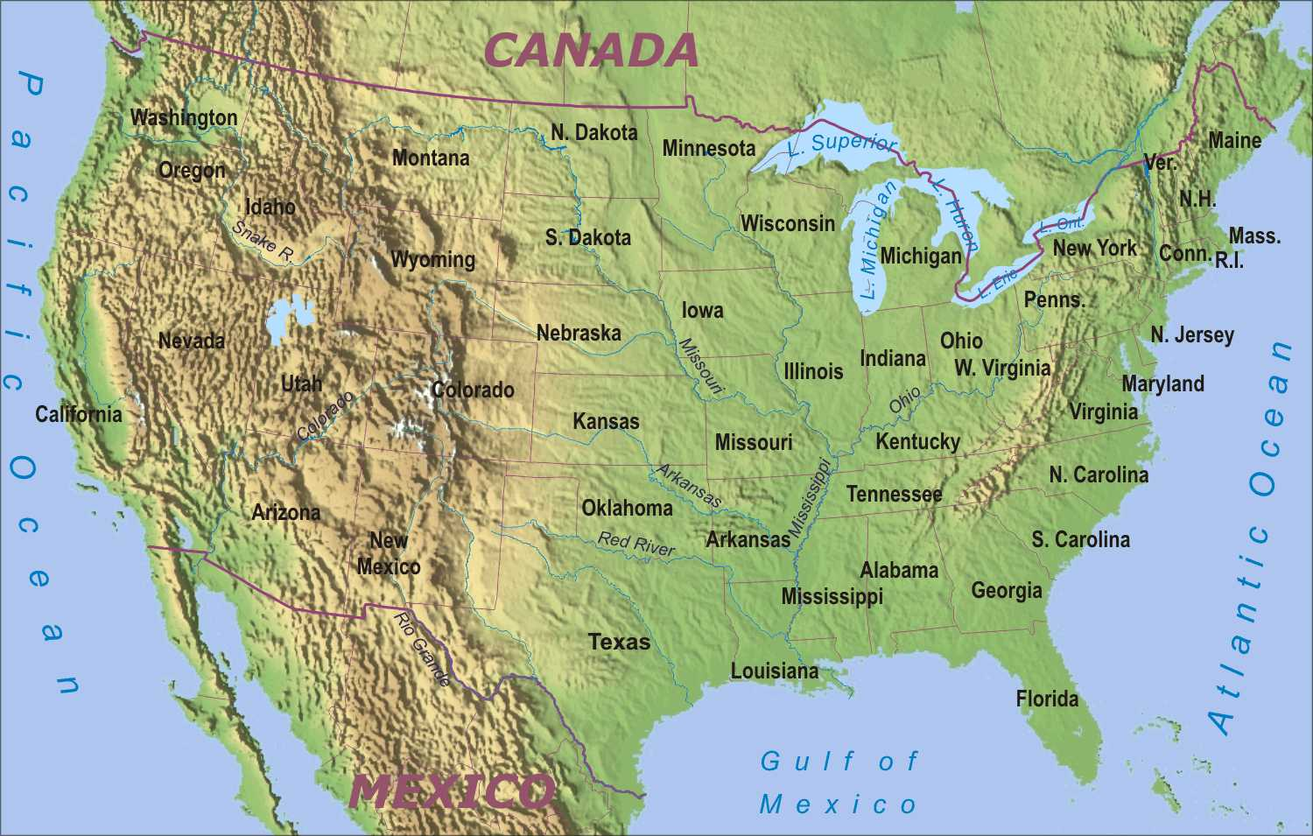

- What type of map is this?
  - Physical Map
  - Resource Map
  - Political Map
  - Road Map

Answer using complete sentences.

- What type of map would you use to find the capital city of Tennessee? Why?

- What type of map would you use to see which state produces the most oil? Why?

